Linnaeus University

1DV700 - Computer Security
Assignment 1

Student: Noa Kron
Personal number: 030530 9411
Student ID: Nk222sj@student.lnu.se

Setup Premises

Windows 11, chrome, pycharm
Task 1

a)
Symmetric encryption – Asymmetric encryption
Symmetric encryption is when both parties have a single key that they use to both encrypt and decrypt the data before they send it. This also means that if someone else manages to get hold of this key they will be able to decrypt everything as well as encrypt new files.
Asymmetric encryption on the other hand works by both parties having 2 keys. One public and one privet. The private key can only encrypt files and the security of this key is not nearly as important as the private key hence the name public. The private key on the other hand can only decrypt files and it can only decrypt files sent from the other person so once you encrypt something you will need the other person to decrypt it for you. Because of that, asymetric encryption is a lot safer.[1]

Encryption algorithms – Hash algorithms
While similar, Encryption algorithms and hash algorithms have very different goals. Hash algorithms are used to shave away data unnecessary for the project, like the positional data of where a word is in a list. This means that while some data is lost you will be able to access the data you want a lot faster meaning hashing is good for sorting and then searching for elements. Encryption algorithms on the other hand is made to loose as little of the original data ass possible while still making it hard to read for unintended eyes. While secure hash functions on the other hand is a mix between the two. Where speed might be less important for better security. It is also worth mentioning that because hashing shaves away unwanted data it is a one way system, meaning you can not undo hashing while encryption is a two way system.[2]

Compression – Hashing
Compression similar to hashing is made to shave of “unnecessary” data but in the goal of making the file smaller instead. It tries to find patterns in the file to express it with an algorithm to save space. Hashing wants to separate data to make it easy to find or as a kind of signature to “prove” that the original file is the one you revived. while compression wants to make it uniform to save on memory or transfer time. This makes both of them into a one way system meaning we can not undo compression on hashing.[3]

b)
Steganography similar to encryption tries make the data hard to read but instead of encrypting steganography tries to hide the fact that the data is even there. A popular way to do this is by hiding the data in the last bits of pixels inside images as the last bits changes the look of the pixels the least. This means that you can hide launch codes to a nuke inside a picture of a puppy, you can quickly see how this might bee a problem for companies or states with important secrets. But on the other hand steganography can be used as digital watermarking showing that you made the picture that you posted to the web. While encryption also can be used for this it is less effective as a perpetrator might just delete the part that clearly is encrypted. Though encryption clearly has its use, for example if you are running a web service and you want to send private data to your customer, it is vastly impractical to use steganography hence why encryption is used in those circumstances. But it is important to mention that they often are used together.

Task 2

a)
The message spells out “Encrypted message” I was not able to avoid using the table as there was very little to go after. No free I/A and no “’s”.

b)
I started of by trying to see if it was a simple Caesar cipher, it was not.
After that I started with the stand alone B in the middle and as A and I are the only single character words in English I knew it had to be one of them. Because of the three letter words before and the structure of the sentence (B not being at the start) I guessed that it would be an A. That would enable me to make an educated guess of the second word and as it is a three letter word with an A at the start it should be either and or are. I started with and but fell short on the fourth word as using an online word finder tool I could not find a suitable word with the structure “?n?d?”[4]. Leading me to the conclusion that the second word should be are. The first word should then be a three letter word with “are a” after it and the word being the subject of the sentence the word “You” was a reasonable guess. Leading to “You are a”, Then I started thinking smart not hard and used an online tool to get “You are a true security him”[5] that did not sound right. So using the same online tool I to guess the last word to be “wiz” as it was a three letter word with an “i” in the middle. Result: “You are a true security wiz”. Last word could also be “Kid” so we can not confidently decrypt the last word but we can make educated guesses.

c)
It was not hard at all to decrypt this message. This is probably the easiest way to encrypt data except just writing in reverse. So making it harder to decrypt is not difficult. Making data harder to decrypt can be as easy as to mix encryption styles. If this would have been both a transpositional and a substitution cipher I would not be able to solve it and the effort to do that is close to none if you use a script to encode and decode for you.

Task 3

My Sub_encrypt works by using the positional value of the letter in the alphabet and adding on the value from the key. Then it takes the letter at the new value and substitutes the old letter with it. The decryption part of my program simply works in the opposite way by subtracting the value of the key and adding 25 if it goes bellow 0.
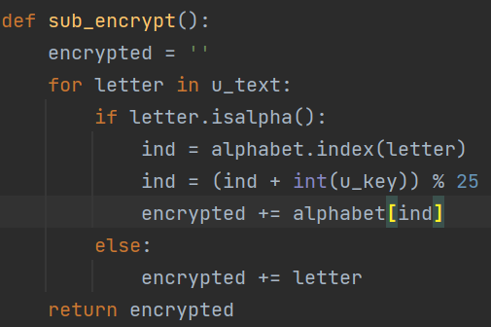

My Trans_encrypt works by making a virtual grid and writing out the words. It does this by using the known size of the X-axis of the grid (The key) and cycles through the letters that many times before considering the next letter to be on the next line. The difference between encrypting manually compared to using code is that you have to think in 1D instead of 2D. So instead of going down when all letters are placed in the grid you jump over the key amount of letters each time, resetting the count when count > len(word_list) to 1 + turn where turn increases with one for every new ‘row’.
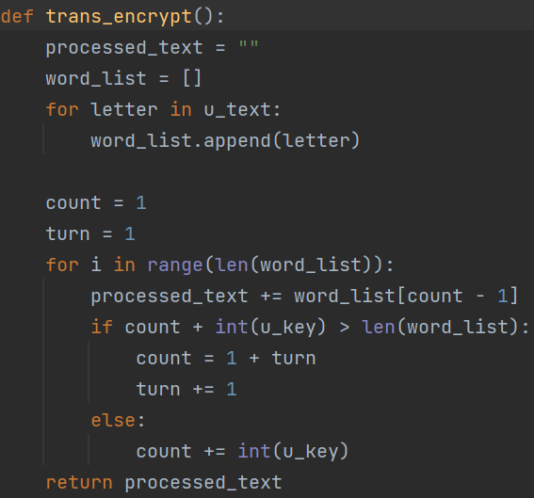

To decrypt a trans message compared to encrypting it is that you have to figure out the size of the Y-axis of the grid by using the key. This is done by taking the total size of the message divided by the key. Similar to encrypting the trick is to think of how you can implement the 2D structure into 1D.
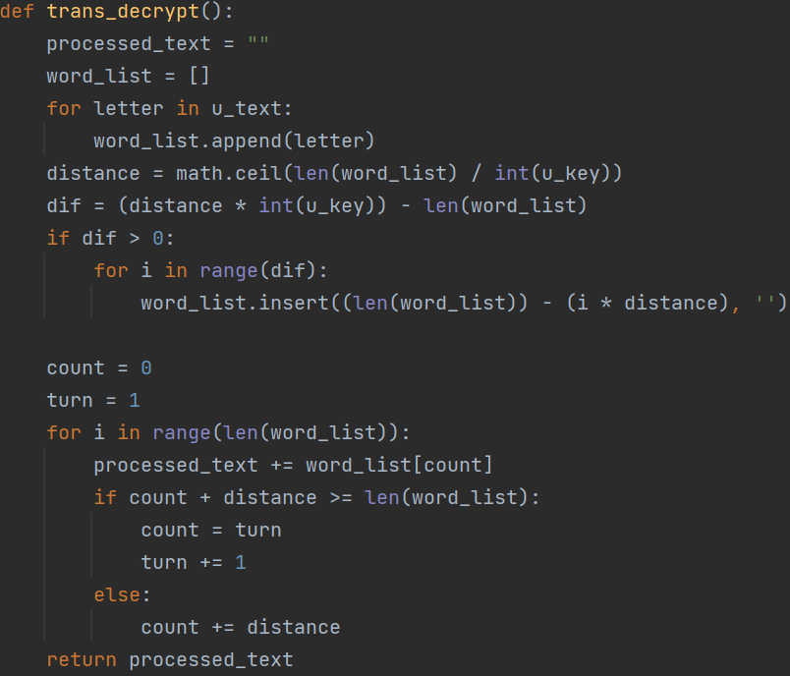

Task 4

My plain text:
Hello this is my encrypted message. Most of this text is just here to enable you to acces the real
secret at the bottom of the page, yes very exiting. I had been thinking that it would be very mean
to have the message just be gibberish, like you just pressed your hand against the keyboard,
luckily for you I did not. our last teacher if you had python programming sure liked starwars huh,
personally am not really a fan.

Now when I am writing this I feel that this might be a bit too hard to decipher for some so here is
the key qwertyuiopasdfghjklzxcvbnm, yes it was me just pulling my finger across my keyboard

Don't know what he meant by at least one page long, that sounded extensive.
Did you get it? no? Too bad because the message is over now.

Good luck!

Secret url:
https://putmeinyoururl.carrd.co/

Noa Kron

The message was encrypted with a simple substitution cipher with the substitution alphabet being “qwertyuiopasdfghjklzxcvbnm”. This key is bigger than 256 but I was told that it was fine by one of the teachers.

Task 5

a)
I started by downloading the cipher made by mh225wd. The first thing I saw when looking at the file was that the “Secret message”- part was also encrypted. This made things easy so I went online to a manual decryption tool and wrote the known sentences from the template into the alphabet. After that I could clearly see it was the lyrics to Bohemian Rhapsody. So I filled in the blanks. That left me with the message:

Is this the real life?
Is this just fantasy?
Caught in a landside,
No escape from reality
Open your eyes,
Look up to the skies and see,
I'm just a poor boy, I need no sympathy,
Because I'm easy come, easy go,
Little high, little low,
Any way the wind blows doesn't really matter to
Me, to me
Mamaaa,
Just killed a man,
Put a gun against his head, pulled my trigger,
Now he's dead
Mamaaa, life had just begun,
But now I've gone and thrown it all away
Mama, oooh,
Didn't mean to make you cry,
If I'm not back again this time tomorrow,
Carry on, carry on as if nothing really matters
Too late, my time has come,
Sends shivers down my spine, body's aching all
The time
Goodbye, everybody, I've got to go,
Gotta leave you all behind and face the truth
Mama, oooh
I don't want to die,
I sometimes wish I'd never been born at all.
The message was encrypted with regards to capital letters leading to the first letter in each row had another plaintext counterpart. Otherwise it was a normal monoalphabetic substitution cipher.

b)
I started by downloading the cipher made by putting the program inside an automatic decrypter[6] and saw that the text was encrypted with a monoalphabetic substitution cipher. I got the final result of:

I WONDER IF YOU HAVE FIGURED OUT WHAT I AM WRITING CHEESE IS YUM AND SO IS PIZZA DONT FORGET TO FLOSS AFTER YOU BRUSH YOUR TEETH AN APPLE A DAY KEEPS THE DOCTOR AWAY NEVER UNDERESTIMATE THE POWER OF CHEESE AND NOW FOR SOME SONG LYRICS BECAUSE THIS IS STUCK IN MY HEAD MY BABY TAKES THE MORNING TRAIN SHE WORKS FROM NINE TILL FIVE AND THEN SHE TAKES ANOTHER HOME AGAIN TO FIND ME WAITIN FOR HER MY BABY TAKES THE MORNING TRAIN SHE WORKS FROM NINE TILL FIVE AND THEN SHE TAKES ANOTHER HOME AGAIN TO FIND ME WAITIN FOR HER SHE TAKES ME TO A MOVIE OR TO A RESTAURANT TO GO SLOW DANCING ANYTHING I WANT ONLY WHEN SHES WITH ME I CATCH A LIGHT ONLY WHEN SHE GIVES ME MAKES ME FEEL ALRIGHT MY BABY TAKES THE MORNING TRAIN SHE WORKS FROM NINE TILL FIVE AND THEN SHE TAKES ANOTHER HOME AGAIN TO FIND ME WAITIN FOR HER ALL DAY I THINK OF HER DREAMIN OF HER CONSTANTLY IM CRAZY MAD FOR HER AND SHES CRAZY MAD FOR ME WHEN SHE STEPS OFF THAT TRAIN IM MAKIN A FOOL A FIGHT WORK ALL DAY TO EARN HER PAY SO WE CAN PLAY ALL NIGHT
NAOMI CHAPMAN

Task 6

a)
My HashSet works by adding the ASCII value of each letter in a word followed by using modulus 256 (amount of buckets) to then place that word into the bucket with the corresponding value. To stress test my hash function I used randomly generated words first as a base line followed by words with 10 symbols differing with only one bit. This was done by changing one of the letters to an adjacent bit value at a time. This was done with 58 symbols so the resulting amount of words generated is 580 and then I ran it backwards giving 1160 unique words with one bit differing.

b)
A function is used that puts random words into the algorithm as a base test, and one that puts very similar ‘words’ to then look for collisions.
We can see that mine had 187 max bucket size while the optimal is 117 with 30000 elements and 256 buckets and a zero bucket ratio of 0.0 for the normal test. This seems to indicate a semi bad hash function as the optimal max bucket size is 70 of from my result.

The avalanche effect is important for hashing, both in the way of security but also to make the spread of elements between the buckets as uniformly as possible. As a rule of thumb every bit changed in the input should change at least 50% of all bits in the output. We can test this by taking the binary value of a word like “hej” and putting it into my hash function to see how the bits change as a result. “Hej” has the binary value of “01101000 01100101 01101010” before going through my hash function. After taking the ASCII value and using mod 256 on it we get 55. as 55 consists of 110111 we now have to check how many bits in the output will change if we change one bit in the input. The binary value of “hek is “01101000 01100101 01101011” which is one bit of from “hej” the result if we plug in “hek” into my hash function is 56 with the binary code of 111000. if we compare the two binary values of we see a change of 110111 and 111000 we do actually see a difference of around 50% but this is just the luck of the draw. If we were to repeat this experiment over time my simple hash function would get a percentage bellow 50%. To improve the percentage of bits changed it is advantageous to use a larger output than input by using hexadecimal for example as many higher level hashing functions does.

For the test with only one bit differing between each new element I got 6 max bucket size out of a possible 4.5, with 1160 elements and a 0.0 zero bucket ratio.
Showing that mine has a bit of collisions, but still not too far from the optimal in regards to the scope of this project. This also indicates uniformity as a large max bucket size indicates low uniformity as well as a high zero bucket ratio but neither is a guarantee and they only serve as indicators, because ¼ of all buckets could have 1 element in them, and the rest have the same amount as the max bucket spoofing both the max bucket size and the zero bucket size indicators. This is unlikely though but that is why we also test for the avalanche effect and when going through the results manually the output shows what the max and zero bucket indicators point towards.

Result from test with random words:
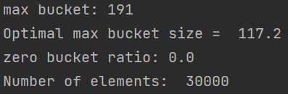

Result from test with closely resembling words (one bit differing):
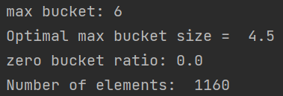

c)
The difference between a secure hash function and a normal function generally works slower. The use of a hash function is that they create a sort of signature for data so that they can be told apart. But because of the limited amount of digits to express this difference. In my case there were 256 buckets. A hash collisions is when two or more words that differ end up having the same hash value. This is a problem if you are using the hash algorithm as a signature to prove that no one has altered the original document, as someone could have found a different document but that has the same hash value and this is why a hash value that is too fast to calculate is really bad for security. One could just make a script to look for documents with the same hash value to find one that changes what they want.

To exploit a normal hash function to manipulate the file without changing the hash would not be harder than to find words that have the same ASCII value as the original. A function that puts random words into the algorithm as a base test and one that puts very similar ones to then look for collisions.
We can see that mine had 187 max bucket size while the optimal is 117 with 30000 elements and 256 buckets.
And for the test with only one bit differing between each new element I got 6 max bucket size out of a possible 4.5, with 1160 elements.
Showing that mine has a fair bit of collisions already, not to speak about the simplicity of using just ASCII values to get the hash of each word.

A secure hash function also takes great use of the avalanche effect. Meaning that a small change in the input makes an almost random output compared to the original.

Bibliography

[1] Charles P. Pfleeger, Shari Lawrence Pfleeger, and Jonathan Margulies. 2015. Security in Computing (Fifth edition ed.). Pearson Education. Pages 116-117

[2] Charles P. Pfleeger, Shari Lawrence Pfleeger, and Jonathan Margulies. 2015. Security in Computing (Fifth edition ed.). Pearson Education. Page 140

[3] https://www.techopedia.com/definition/884/data-compression

[4] https://wordfinder.yourdictionary.com/unscramble/h_llo/

[5] https://www.boxentriq.com/code-breaking/cryptogram

[6]https://www.dcode.fr/monoalphabetic-substitution

